**“FUNDAMENTALS OF PROGRAMMING”**

**Course Instructor:** Dr. Khwaja Fahad Iqbal

**Lab instructor:** Sir Muhammad Affan

**Submitted by:** Momina Haq

**CMS ID:** 468932

ME -15 SECTION B

**TASK: 01 “Create a program that takes a student's score as input and assigns a grade based on predefined criteria using logical operators (e.g., A, B, C, D, F).**

**A-Grade: 90-100 Marks**

**B-Grade: 75-90 Marks**

**C-Grade: 60-75 Marks**

**D-Grade: 45-60 Marks**

**F-Grade: 0-45 Marks**

#include <iostream>

Include namespace std;

int main() {

int score;

//A variable with the name “score” is declared

//The user is asked to enter the marks of the student

//The given value will be stored in the variable.

cout << "Enter the student's score: ";

cin >> score;

//using the if else logic along with the “AND” operation,

//the range of marks are designated for a particular grade.

if (score >= 90 && score <= 100) {

cout << "The student's grade is: A" << endl; }

else if (score >= 75 && score < 90) {

cout << "The student's grade is: B" << endl;}

else if (score >= 60 && score < 75) {

cout << "The student's grade is: C" << endl;}

else if (score >= 45 && score < 60) {

cout << "The student's grade is: D" << endl;}

else {

cout << "The student's grade is: F" << endl;

}

return 0;

}

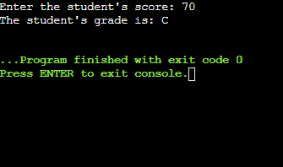

**TASK: 02 “Write a program that takes an integer as input and determines if it is both even and divisible by 5.”**

#include <iostream>

using namespace std;

int main() {

int num;

//A variable with the name “num” is declared.

//The user is asked to enter the integer.

//The given value is stored as the value for the variable.

cout << "Enter an integer: ";

cin >> num;

//Using the if else logic along with the “AND” operation,

//we say that if the number is divisible by both 2 and 5,

//the program interprets this result to the user.

if (num % 2 == 0 && num % 5 == 0) {

cout << "The number is both even and divisible by 5." << endl;}

else {

cout << "The number is not both even and divisible by 5." << endl;}

return 0;

}

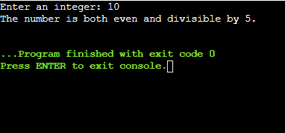

**TASK: 03 “Create a C++ program that checks if a user-provided year is a leap year.”**

#include <iostream>

using namespace std;

int main() {

int year;

//A vairiable with the name "year" is declared,

//The user is asked to enter a year,

//which they want to determine if its a leap

//year or not.

cout << "Enter a year: ";

cin >> year;

if (year % 4 == 0 ) {

//since a leap year repeats after every four years,

//we say that if the year given by the user is

//divisible by 4,the year given will be a leap year,

//if not it will not be a leap year.We use the modulus (%) function

//to check if the year is divisible by 4.we use an if else

//function to show the results.

cout << "The year "<<year<<" is a leap year."<<endl;}

else {

cout << "The year "<<year<<" is not a leap year." << endl;}

return 0;

}

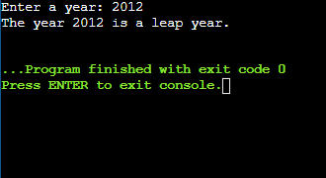

**TASK: 04 “Create a C++ program that determines if a student is eligible for a scholarship based on their GPA (must have GPA >= 3.5) and attendance (must have attended at least 80% of classes).”**

#include <iostream>

using namespace std;

int main() {

float gpa,attendance ;

//Two vairables namely "gpa" and "attendance" were declared

//The user is asked to provied the gpa and attendance percentage of the student.

cout << "Enter the student's GPA: ";

cin >> gpa;

cout<<"Enter the students attendance percentage: ";

cin>>attendance;

//if the gpa and attendance BOTH are above or equal to the specified limit,

//the program will show that the student is eligible for the scholarship

//or vice versa if the conditions are not fulfilled.

//Here both the "AND" operation and if else logic is used.

if ((gpa>=3.5)&&(attendance>=80) ) {

cout << "The student is eligible for scholarship. "<<endl;}

else {

cout << "The student is not eligible for scholarship." << endl;}

return 0;

}

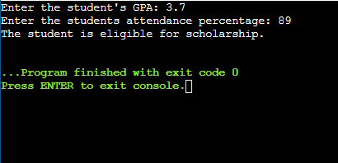

**TASAK: 05** **“Write a program that checks if a given character is a vowel (a, e, i, o, u) or a consonant using logical operators.”**

#include <iostream>

using namespace std;

int main() {

char letter;

//A variable with the name "letter" is declared.

//The user is required to input an alphabet that

//will be stored in the variable.

cout << "Enter the alphabet: ";

cin >> letter;

//using the “if else” logic and the "OR" operation.

//If the given alphabet is any of the letters given

//in the "OR" operation, the program will tell the

//user that the given alphabet is a vowel,in case of

//any other letter, it will be decalred a consonant.

if (letter == 'a' || letter == 'e' || letter == 'i' || letter == 'o' || letter == 'u') {

cout << "The given alphabet is a vowel. "<<endl;}

else {

cout << "The given alphabet is a consonant." << endl;}

return 0;

}

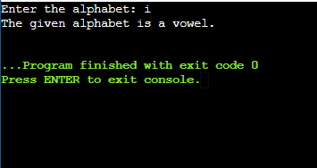

THE END.